**Step-by-Step Student Instructions** for using **Office 365-Word Online**

to create and share documentswith me!

1. Login to the computer using **your login** (Username: Student ID number & Your Password)
2. Open a web browser (Chrome, Internet Explorer, or Firefox)
3. Go to the web **address bar** at the top of the window and **type this in this URL** [**http://office365.leonschools.net**](http://office365.leonschools.net)to setup/login to your **Leon County Schools Office 365** account.

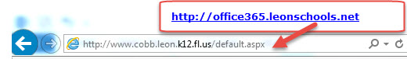

1. Your Office 365 account username is your **9 digit student ID number followed by @edu.leonschools.net** (for example- 123456789@edu.leonschools.net) **&** your password is the **same password you use to login to the computer**.

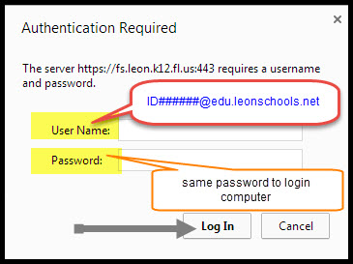

1. It will start the **Outlook Web App** & complete first-time setup by Selecting Time Zone **Eastern (US & Canada)**.
2. 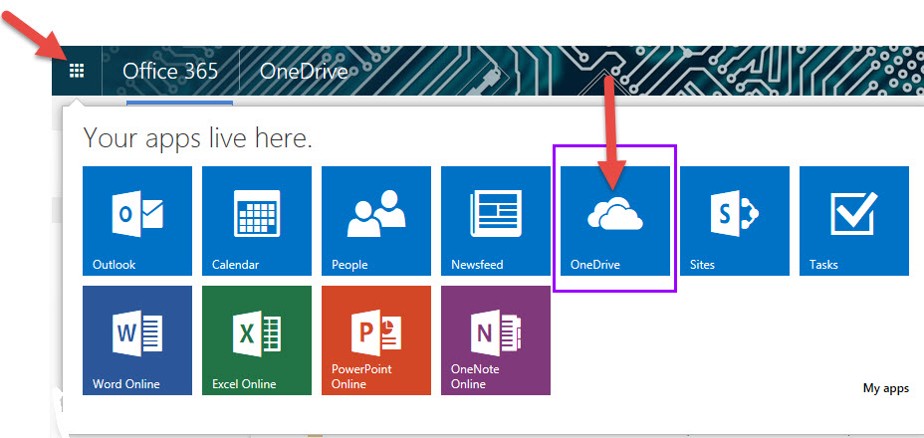Click on Office 365 Quick Launch icon (looks like square boxes) in **Upper Left Corner**

1. Click **OneDrive**, then go to **+new** then **Word Document**

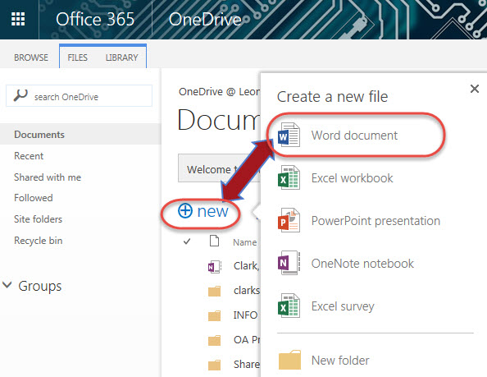

1. Start typing your work!
2. There is no need to “save” your work, it’s saved for you as you go.
3. After you have finished typing your essay, or if the time is up,

select **Share** button in upper right corner

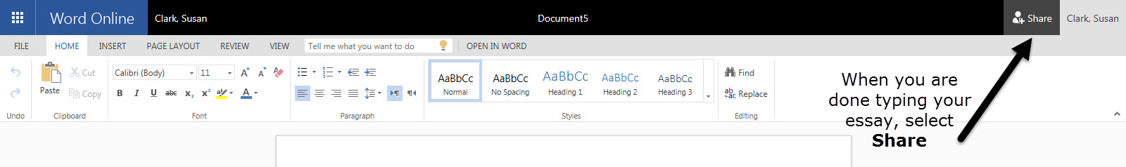

1. In the **Share** dialog box on the **Invite People** tab, type harrington, and select Harrington, Day.It will put my name in the Invite People box.
2. Select a permission setting- **Can edit**
3. If you want, type a message to be included with an email that’s sent to all invitees. The email includes a link to the shared document.
4. Click **Share** button… A brief message will show up under the Share button  saying the “DOCUMENT” was shared with …………………….the teacher’s name you selected.